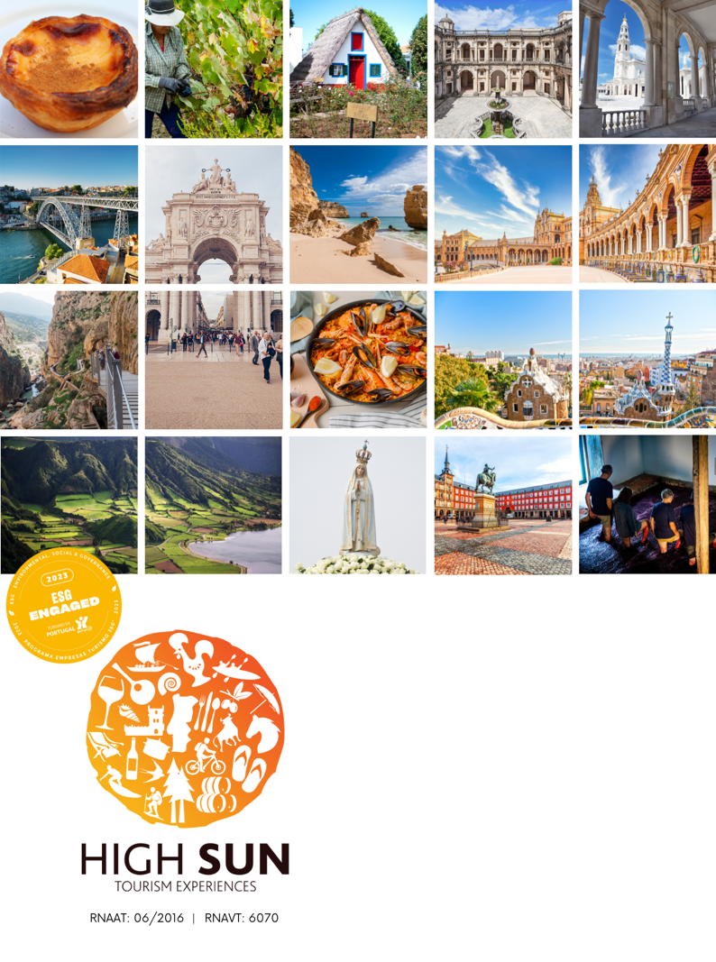
New Year traveling through Portugal
8 days/ 7 nights
CONTACT US: sales@highsun.pt - (+351) 249 819 250 - VISIT US: https://highsun.pt/en/ - FOLLOW US: Instagram | Facebook | Linkedin

Lisboa Plaza Hotel 4* or similar
Accommodation
4 nights in BB Regime
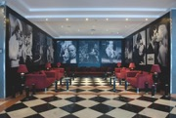
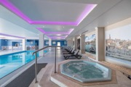
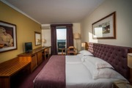



Vila Galé Porto Hotel 4* or similar
Accommodation
2 nights in BB Regime
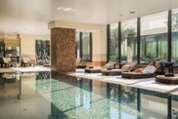
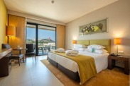
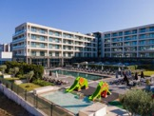
Vila Galé Coimbra Hotel 4* or similar
Accommodation
1 night in BB Regime

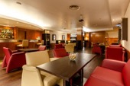
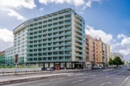

Hotel Roma 3* or similar
Accommodation
4 nights in BB Regime

Holiday Inn Express Porto Boavista 3* or similar
Accommodation
2 nights in BB Regime
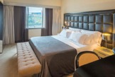





NH Coimbra Dona Inês 4* or similar
Accommodation
1 night in BB Regime

Program

Day 1 – Arrival at Lisbon
Arrive at Lisbon Airport and then head to the hotel 3* or 4*.
Rest of the day at leisure.

Day 2 – Lisbon

Breakfast at the hotel followed by a half-day tuk-tuk tour exploring Lisbon’s main tourist attractions.
Return to the hotel to rest before welcoming the New Year.

Celebrate with dinner at one of Lisbon’s incredible restaurants or join the festivities in the streets, particularly at Praça do Comércio, with live concerts and fireworks (not included).
Return to the hotel and overnight stay.

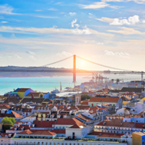
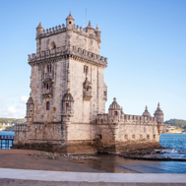
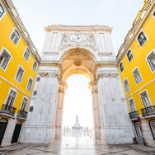
Day 3 – Lisbon
Breakfast at the hotel.
Enjoy a free day to celebrate the New Year while discovering the beautiful city of Lisbon at your own pace.
Return to the hotel and overnight stay.

Day 4 – Lisbon / Óbidos / Nazaré / Aveiro / Porto
Breakfast at the hotel and check-out, head towards Porto, the "Unconquered" city.
Along the way, enjoy several stops to explore hidden gems of Portugal.
The first stop is the charming town of Óbidos, a medieval village enclosed by ancient walls. Visit the Church of Santa Maria, home to paintings by Josefa de Óbidos, and stroll through the cobbled streets to admire local crafts and sample the famous ginjinha liqueur.
Next, visit Nazaré, a traditional fishing village. At the “Sítio”, enjoy stunning views over the beach of Nazaré. The final stop before Porto is Aveiro, known as the “Portuguese Venice”. Crossed by canals – authentic water streets – here you can watch the colourful moliceiro boats glide by and sample the region’s traditional sweet, ovos moles. Continue the journey to Porto.
Arrival and check-in at 3* or 4* hotel.

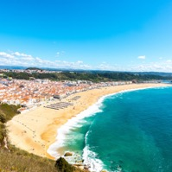
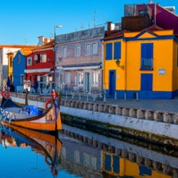
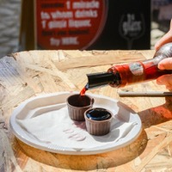
Breakfast at the hotel.
In the morning, enjoy a walking private tour of Porto with a local guide. Visit the UNESCO-listed historic centre, the Ribeira district, Clérigos Tower, the Cathedral, Palácio da Bolsa, and other notable landmarks.
In the afternoon, visit a Port Wine Cellar with a tasting session. Remainder of the day at leisure.
Return to the hotel and overnight stay.
Day 5 – Porto

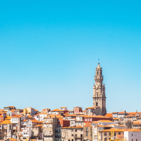
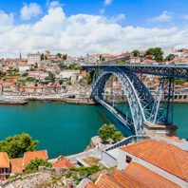
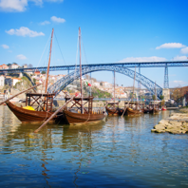
Breakfast at the hotel and check-out.
Head to Coimbra, one of Portugal’s most beautiful and historic cities, nestled along the banks of the River Mondego. Known as the “City of Students”, it is home to Portugal’s first university – one of the oldest in Europe and a UNESCO World Heritage Site.
Overnight stay at 3* or 4* hotel.
Day 6 – Porto / Coimbra

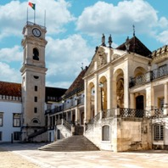
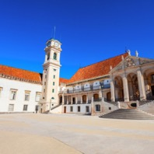
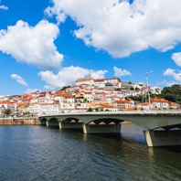
Breakfast at the hotel and check-out.
Before returning to Lisbon, stop in Tomar – former headquarters of the Knights Templar – where you may visit the Convent of Christ, a UNESCO World Heritage Site, as well as the Synagogue and the Church of São João Baptista. Continue your journey to Lisbon and check-in at the hotel.
In the evening, enjoy a farewell dinner accompanied by a live Fado performance.
Return to the hotel and overnight stay at 3* or 4* hotel.

Day 7 – Coimbra / Tomar / Lisbon

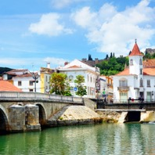
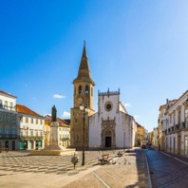
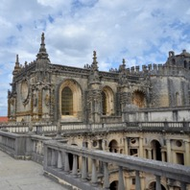
Breakfast at the hotel and check-out.
Head to Lisbon Airport and board your selected flight.

Day 8 – Lisbon

945€
Price for 3* Hotels, from

Price per person in double room sharing/ in euros / NET / VAT included
Price for 4* Hotels, from
1.628

Price per person in double room sharing/ in euros / NET / VAT included

INCLUDED
- Accommodation in the hotels 3* mentioned or similar in BB regime;
- Tuk Tuk Tour Lisbon half day;
- Walking Tour Porto Half day;
- Tour for Port Wine Cellar with testing session;

OPTIONAL
- Rent a car (optional):
- Pick-up station: Lisbon Airport;
- Drop-off station: Lisbon Airport;
- Code: ACRISSMBMR;
- Car: Fiat 500 or similar - Class Mini, 2-door, manual, A/C.


NOT INCLUDED
- Suggestions in the itinerary;
- Travel/Covid-19 health insurances;
- City taxes;
- Flights & Visas;
- Personal Expenses;
- Any items or subjects not mentioned as included.

GENERAL CONDITIONS
- Special offer, rates and availability must be confirmed at booking.
- Offer subject to limited availability of stock and services.
- If unavailable, an equivalent alternative will be proposed, pending client approval.
- Valid until travel date or while availability lasts.
- Full prepayment required at time of booking.
- Free cancellation up to 15 days before departure; non-refundable thereafter.
- Pricing based on the indicated number of participants; changes may affect total cost.
- HighSun is not liable for unfulfilled activities due to weather or external factors.




Boa tarde Inez, Espero que este mail a encontre bem,
Remeto em anexo um roteiro de Ano Novo para Portugal. Este roteiro dá a oportunidade de conhecer vários cantos de Portugal. Envio também uma Special Offer de Outuno, para Viana do castelo uma bela cidade localizada no norte de Portugal na zona do minho.
Por fim envio uma noticia para partilhar nas suas redes, onde refere que Portugal foi distinguido como melhor destino Europeu o que comprova que Portugal é o destino certo para quem gosta de viajar.
Alguma duvida esteja à vontade para perguntar.
Obrigado
Com os melhores cumprimentos.

