

India with Bhutan

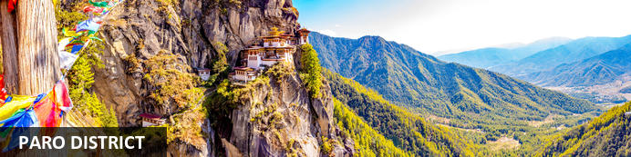
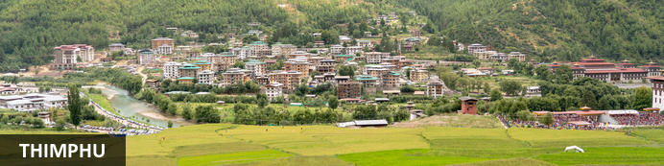
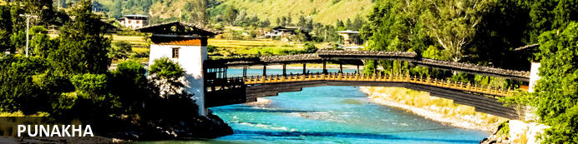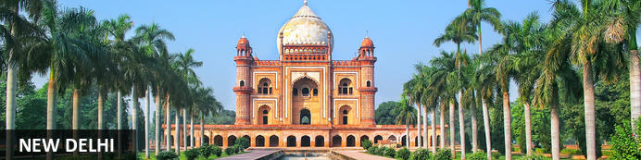

India with Bhutan
New Delhi – Paro – Thimphu – Punakha – Paro – Delhi
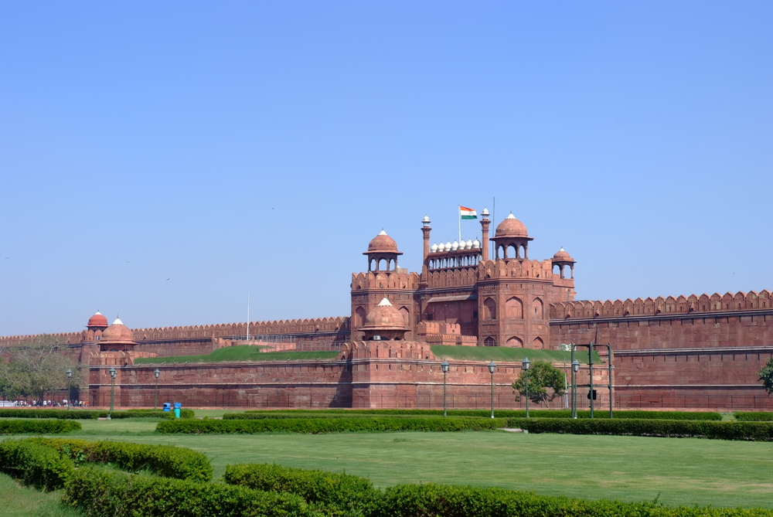
Detailed Itinerary
04th Apr - Arrival in Paro (BY: Flight)
Paro – Thimphu (1.5 Hrs)
Your Tour begins with your arrival at the Paro International. Upon your arrival in Paro airport our guide will be there to welcome you and transfer to Thimphu.
Check in to the hotel and go for the traditional hot stone bath and relax to acclimated yourself

Overnight at the hotel
Meals – Breakfast & Dinner

05th Apr - Thimphu Sightseeing
Morning visit the happening (Kaja Throm) market where the locals from the surrounding villages come to sell their produce. They sell their goods and in return they buy their basic necessities. In olden days, bata system was practiced by everyone. Visit the traditional Hand Made Paper Mill which is a small cottage factory practicing the old ways of making paper. Visit the School of Arts and Crafts where students learn 13 different arts used predominantly in Bhutan. Visit Folk Heritage Museum which explains how a traditional house used to be like in the olden days. Later in the afternoon visit the Memorial Chorten (temple) built in memory of the late 3rd King. This place now happens to be a get together point for the elderly people, who spend their whole day chanting prayers and meeting their friends. Visit the largest and the newly built statue of Buddha offering 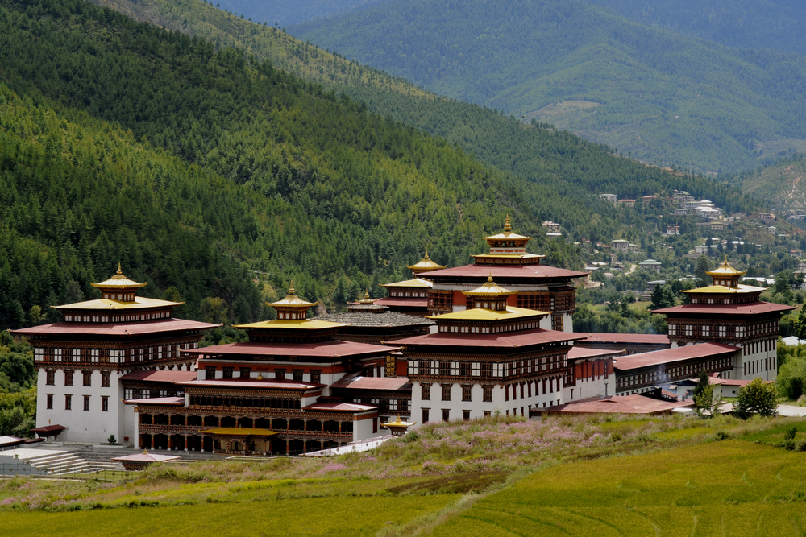magnificent view of entire Thimphu valley. After 5 PM, visit the fortress of Thimphu, Tashichho Dzong, which houses the throne of the king.

Overnight at the hotel
Meals – Breakfast, Lunch & Dinner

06th Apr- Thimphu- Punakha (2 Hrs)
After breakfast check out from the hotel and drive to Punakha crossing over Dochula pass (3200 mts). If the After breakfast check out from the hotel and drive to Punakha crossing over Dochula pass (3200 mts). If the weather permits one can enjoy a spectacular breath-taking view of the highest mountain peaks of Bhutan at a sight that stretches almost 180 degrees. Take a break and walk around the newly built 108 stupas and continue to the sub-tropical valley of Punakha offering different vegetation.
En route just before arriving the hotel, taka a nice hike through the paddy field and old village to visit Chimi Lakhang, the temple of fertility associated with religious art of phallus.
After lunch visit Punakha Dzong (fortress), which houses the most elaborated temple in the country. This is a must to see fortress in Bhutan and a fine example of Bhutanese rich Art and Architecture. After the visit walk towards the longest suspension bride of Bhutan (520feet). After lunch could relax in the balcony of the hotel to enjoy the view and the nature.

Overnight at the hotel
Meals – Breakfast, Lunch & Dinner

07th Apr - Punakha, TALO TSECHU Talo Monastery, (Punakha 5th – 7th April)
Morning drive to Talo Monastery and enjoy the Talo festival and witness the beautiful traditional and cultural. You will also get to meet the local people and chat with them.

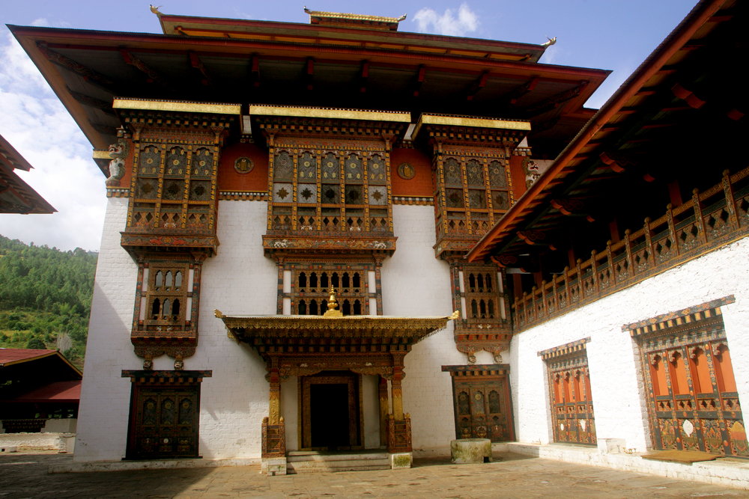
Afternoon drive back to the hotel Or could go for an hour hike (uphill) to the temple of Khamsum Yuley Lakhang overlooking the paddy field and the snakelike river bends. Later back to the hotel.

Overnight at the hotel
Meals – Breakfast, Lunch & Dinner

08th Apr - Punakha – Phobjikha (2 Hrs)
Morning start retracing your drive to the remote isolated valley of Phobjikha. The drive is very picturesque and worth every turn and climb. This valley is protected being winter home for the endangered Black Necked Cranes migrating to Bhutan every end of Oct to end of Feb. This valley is a paradise for the nature lovers and hikers. Start with one of the best hike which is not hard and it is worth hiking. This breathtaking hike, Gangtey 360°, begins with a 15 minute drive back up towards Lawala Pass. From here you will set off on a 30-40 minute hike up towards the meditation cliff at 3,400m. The hike takes you up a sloping lined pathway, through towering bushes of jade-hued bamboo. When you reach the top you are rewarded with unobstructed 360° views on all sides; Phobjikha (Gangtey) Valley as far as the eye can see and the Himalayas. Walk along
the ridge line to see the secluded meditation huts before the spectacular views. Afterwards head down the ridge towards the Shedra (monk college) arriving back at the base approx.
Later in the afternoon you will visit this 7th century shrine known as Kichu lakhang, which marks the introduction of Buddhism in Bhutan and is one of the two oldest shrines in the kingdom. Built by the Tibeten King, Songtsan Gampo, the shrine contains one of the Paro Valley's greatest treasures, an original 7th Century statue of Buddha which attracts thousands of pilgrims each year.

Overnight at the hotel
Meals – Breakfast, Lunch & Dinner

09th Apr - Phobjikha sightseeing.
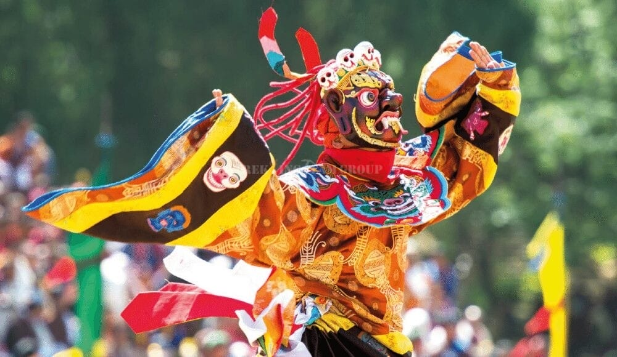
Today will be a very relaxing day. Morning could go for walk right below your hotel and meet the school children who all walk for hours to reach their nearest school. Or if you want to relax and start very late, today is the right day to make it happen. After late breakfast could go for Phobjikha Nature trail hike (2.5 Hrs), which offers beautiful view of the valley. If you want to hike more, then you can start hiking from the hotel and end in Gangtey Goempa, which will be a loop for half a day. It starts from the valley and end with Gangtey Goempa temple at the hilltop overlooking the valley. Gangtey Goempa temple is a beautiful temple, richly renovated with many monks living. Gangtey is also the best place to connect with people and learn more about Bhutanese culture, art and tradition.

Overnight at the hotel
Meals – Breakfast, Lunch & Dinner

10th Apr - Phobjikha – Paro (4.5 Hrs.)
Morning drive to drive back to Paro.After reaching Dochula pass (3200 m) In Paro visit the Paro Musuem (watchtower), built in 1649 to protect the undefended dzong and renovated in 1968 to house the National Museum. The unusual round building is said to be in the shape of a conch shell, with 2.5m-thick walls. The Ta dzong suffered damage in the 2011 earthquake but reopened in 2019 as the nation's premier museum.
Later in the afternoon you will visit this 7th century Kichu Lakhang, shrine, which marks the introduction of Buddhism in Bhutan and is one of the two oldest shrines in the kingdom. Built by the Tibeten King, Songtsan Gampo, the shrine contains one of the Paro Valley's greatest treasures, an original 7th Century statue of Buddha which attracts thousands of pilgrims each year.
Overnight at the hotel
Meals – Breakfast, Lunch & Dinner

11th Apr - Paro festival (8th-12th April)

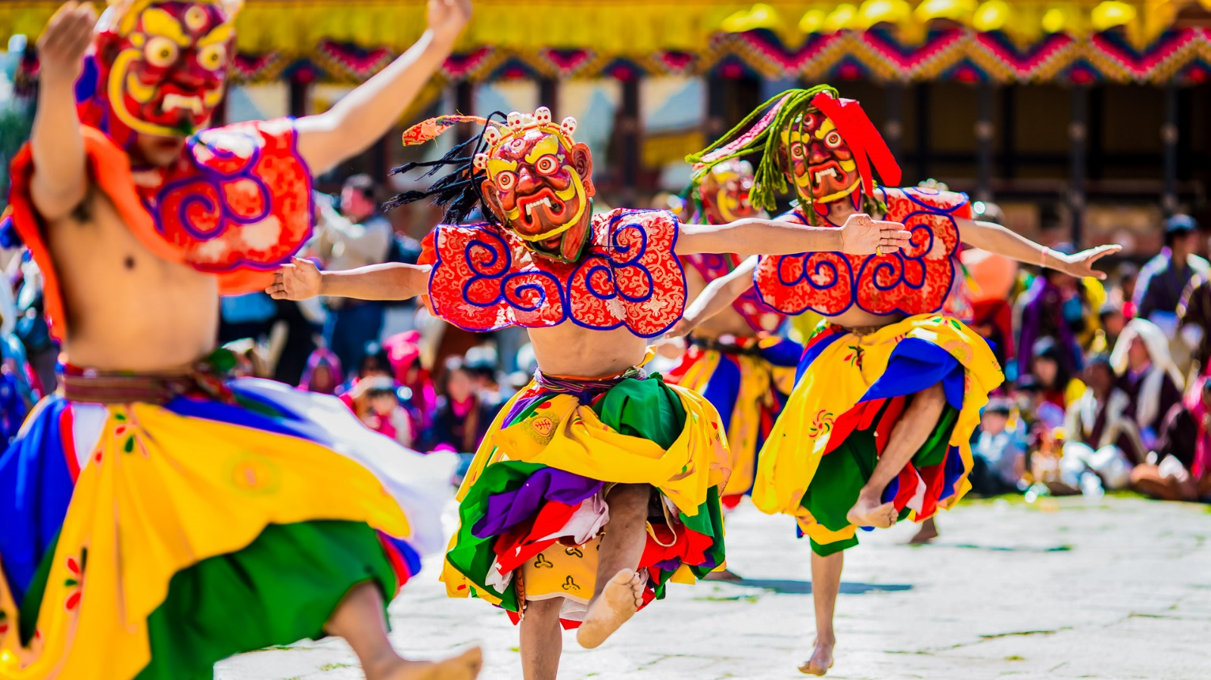
Later after breakfast retrace your drive to Paro fortress and visit the festival. Annual Paro Tshechu, Bhutan’s largest and most resplendent festival. Masked dancers perform ritualized reenactments of mythical struggles between good and evil forces. Accompanied by Tibetan musicians and the antics of the sacred clowns (atsaras), the Tshechu is a fascinating visual and cultural spectacle unique to Bhutan. Evening relax at your hotel.

Overnight at the hotel
Meals – Breakfast, Lunch & Dinner

12th Apr - Paro, Chelela excursion (1.2 Hrs one way.) & festival
Morning visit the festival for the last day to witness the giant wall painting back from 17th century which is shown to the people only once a year.

Chele La Pass is one of the highest road points in Bhutan and offers breathtaking views of the mountains. It is situated at an elevation of 3,988 meters/13,084 feet between the Paro and Haa valleys. The drive to Chela La Pass from Paro is as charming as the Mountain Pass itself. It is just over 36 km to the pass.
The Chele La pass is at a cool crisp mountain pass and your route takes you through a spectacularly lovely forest of pine, oak and rhododendrons that ablaze with blood red and pink blooms in April and May. Once you cross the tree line, you are likely to come up with yaks grazing in the alpine meadows. The pass itself is marked by a multitude of prayer flags that seem to spear the intense blue skies! On a clear day, you can get
a breathtaking view of Mt. Jomolhari (2nd highest mountain in Bhutan) and other Himalayan giants. You can have some good pictures and hike around the pass.

Overnight at the hotel
Meals – Breakfast, Lunch & Dinner

13th Apr - Paro Sightseeing
Morning drive to the base for the hike (3 hrs uphill) to Tiger’s Nest, the most revered temple in the country that literally hangs on a granite cliff overlooking the Paro valley. Most of the day will go on the hike.
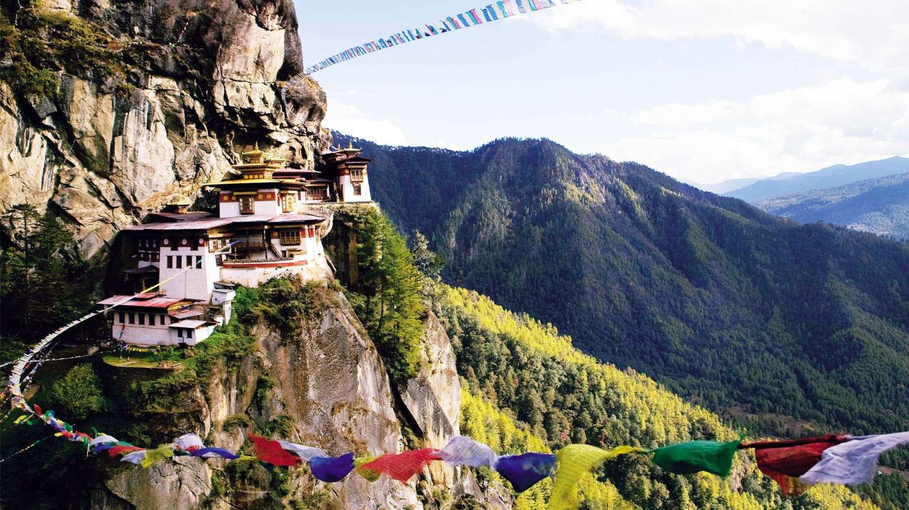

Afternoon if you have energy then you can again visit the festival. Hot stone bath available at an additional cost.

Overnight at the hotel
Meals – Breakfast, Lunch & Dinner

14th Apr – Paro – Delhi (By: Flight)
Morning transfer (15 mins) to the airport for your departure flight. Your guide will bid you farewell at the airport.

Or arrival at Delhi, you will be received by a Trans India Holidays representative and he will escort you to the hotel and help you with the check in formalities.

Overnight at the hotel
Meals – Breakfast
15th Apr – Delhi
Day at leisure to explore city of you own & shopping.

Set Dinner confirmed at Haveli Dharampura.
Overnight at the hotel
Meals – Breakfast & Dinner

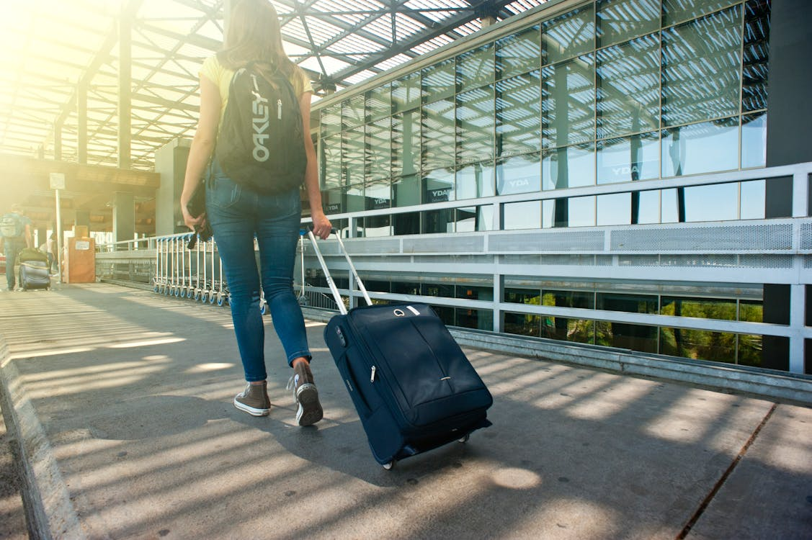

16th Apr – Delhi – Departure (By Flight)
Intime transfer to the airport to board the flight for onward destination

Meals – Breakfast
****End of Tour****

