

------------------------------------------------------------------------------------------------------------------------------------------------------------
PROPOSED ITINERARY
REFERENCES:  Our Ref: | LEAD TRAVELER/AGENT DETAILS:  Name:  Email:  Phone:
Day 1: Nairobi  DAY HIGHLIGHT  Destination: Nairobi  Accommodation:  3-star Hotel Golden Tulip Hotel  4-star Hotel Sarova Stanley Hotel  5-star Hotel Villa Rosa Kempinski  Room Configuration: Standard Double Rooms  Meal Plan: Bed & Breakfast  --------------------------------------  Arrival at JKIA Airport, where you will be met by our team outside the customs and immigration halls and be briefed on your safari.  Later drive to the hotel and check-in in anticipation of what Kenya holds for you.  Dinner and overnight  --------------------------------------  Extras Activities:  - Dinner - $55  - Giraffe center - $15  ***Extra’s are charged separately | Pictorial Experience Highlight:  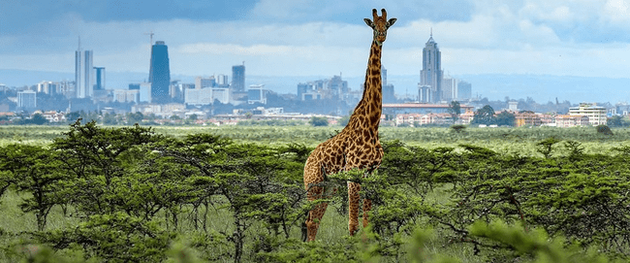  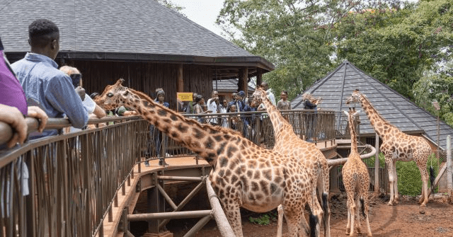
Day 2:Nairobi - Amboseli National Park  DAY HIGHLIGHT  Destination: Amboseli National Park  Distance Covered: 211 KM  Time: Approx. 4hrs 30min  Accommodation:  3-star AA Lodge Amboseli  4-star Amboseli Sopa Lodge  5-star Ol Tukai Lodge  Room Configuration: Standard Double Rooms  Meal Plan: Full Board ( Breakfast,Lunch & Dinner)  --------------------------------------  Breakfast and proceed to Amboseli National park. Check in at your lodge for lunch and in time for leisure in the afternoon. Amboseli National Park is Known for its great elephant herds and the guides are experts at teaching their guests about these animals’ complex social interactions and the dramatic views of Kilimanjaro, the highest free standing mountain in the world, and the highest peak on the African continent.  Later in the evening, have a game drive at Amboseli National Park.  Dinner and overnight.  --------------------------------------  Extras Activities:  - N/A  ***Extra’s are charged separately | Pictorial Experience Highlight:  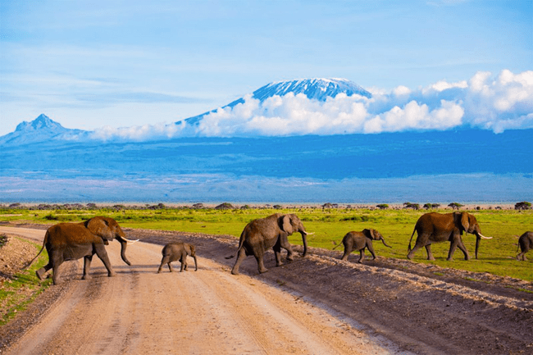  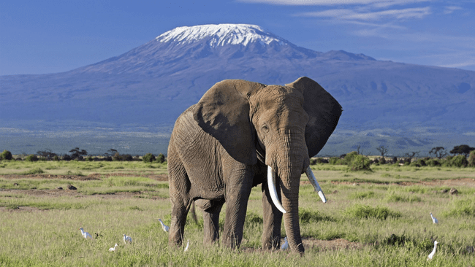
Day 3: Amboseli National Park  DAY HIGHLIGHT  Destination: Amboseli National Park  Accommodation:  3-star AA Lodge Amboseli  4-star Amboseli Sopa Lodge  5-star Ol Tukai Lodge  Room Configuration: Standard Double Rooms  Meal Plan: Full Board (Breakfast, Lunch & Dinner)  ------------------------------------------------  Breakfast at the lodge then proceed for a morning game drive in the reserve.  Lunch at the lodge. Afternoon, relax while enjoying the lodges facilities, e.g. the swimming pool, spa etc. At 1600hrs, embark on an afternoon game drive in the reserve until sunset. During this time, you can visit the Masai village and learn their way of living and dance.  Dinner & Overnight at lodge.  -------------------------------------------  Extras Activities:  - Masai village $20 Per Person  - Hot Air Balloon $450 Per Person  ***Extras are charged separately | Pictorial Experience Highlight  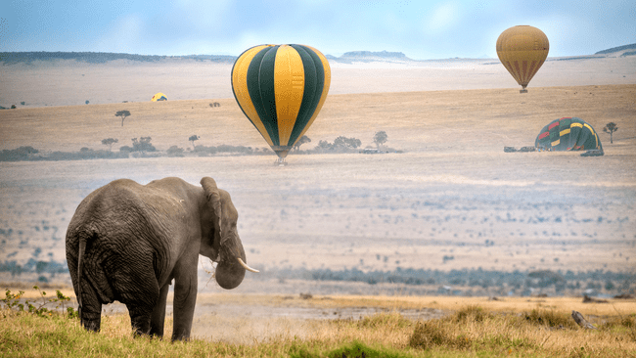  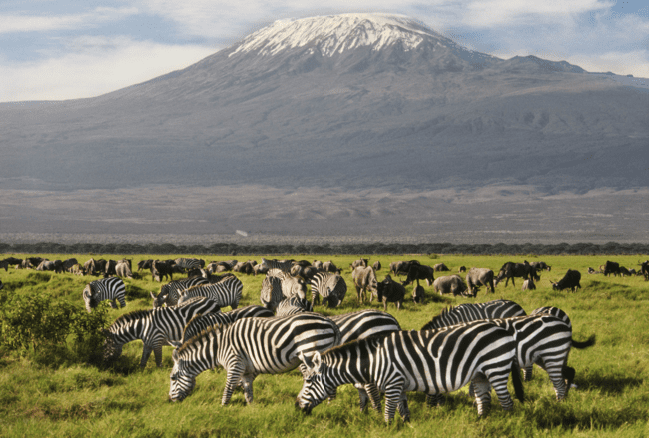
Day 4 :Amboseli National Park - Lake Naivasha  DAY HIGHLIGHT  Destination: Lake Naivasha  Time: Approx. 6hrs  Accommodation:  3-star Naivasha Kongoni Lodge  4-star Lake Naivasha Sopa  5-star Enashipai Resort  Distance Covered: 302 KM  Time: Approx. 6hr  Room Configuration: Standard Double Room  Meal Plan: Full Board (Breakfast, Lunch & Dinner)  --------------------------------------  Breakfast, check out then depart for Lake Naivasha.  Arrival & Check in at your charming Lake Naivasha Lodge which overlooks the serene lake.  Enjoy your lunch. In the afternoon your driver will take you to Lake Naivasha for a leisurely boat ride meeting hippos and witnessing the rich birdlife of lake Naivasha and a (optional) visit to Crescent Island which is ideal for walking safari.  End the day with a delectable dinner at your lodge, under a starry African sky and overnight.  --------------------------------------  Extras Activities:  - Crescent island $33 per person  ***Extra’s are charged separately  -------------------------------------- | Pictorial Experience Highlight:  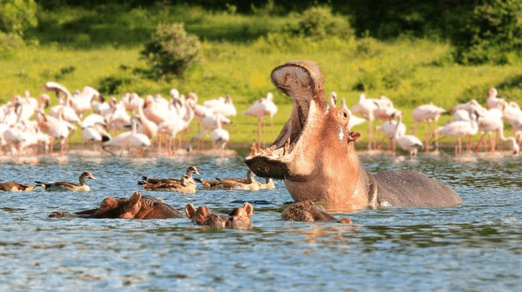  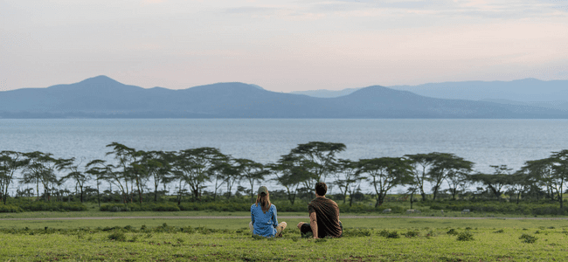  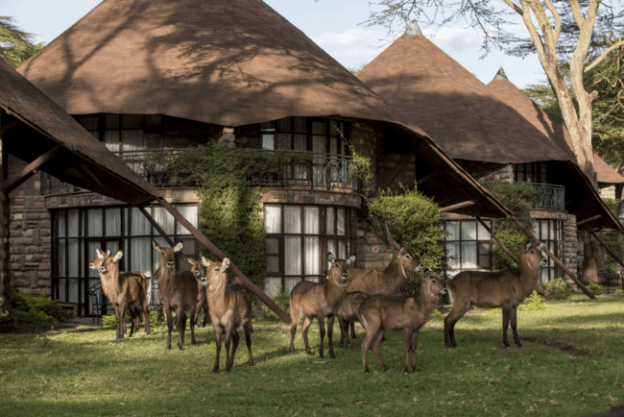
Day 5: Lake Naivasha - Maasai Mara National Reserve  DAY HIGHLIGHT  Destination: Maasai Mara National Reserve  Distance Covered: 145.2 Km  Time: Approx. 4 Hours  Accommodation:  3-star Enkorok Mara Camp  4-star Masai Mara Sopa Lodge  5-star Mara Maisha Camp  Room Configuration: Standard Double Room  Meal Plan: Full Board (Breakfast, Lunch & Dinner)  --------------------------------------  Enjoy a hearty breakfast and embark on the exciting journey to the renowned Maasai Mara National Reserve.  Arrive in time to chow down on a scrumptious lunch and later in the afternoon, hop into your safari vehicle, ready to embark on a game drive that's wilder than a lion's roar. Your guide is your GPS in this animal-packed wonderland, so pay attention!  The Maasai Mara is like the fashion runway of the animal kingdom. Be ready for lions, cheetahs, leopards, and a parade of other fabulous creatures.This wild afternoon at Maasai Mara National Park is your golden ticket to a memorable safari experience. From animal encounters to sunset toasts, it's a day you won't soon forget!  Return to your lodge for a lavish dinner and overnight.  --------------------------------------  Extras Activities:  - N/A  ***Extras are charged separately | Pictorial Experience Highlight:  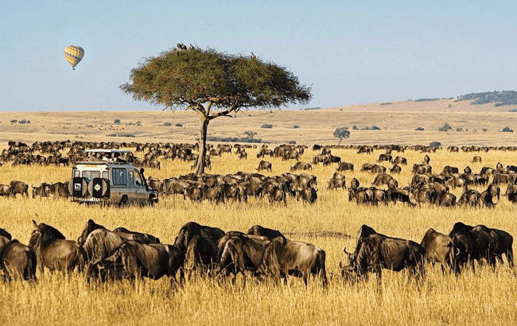  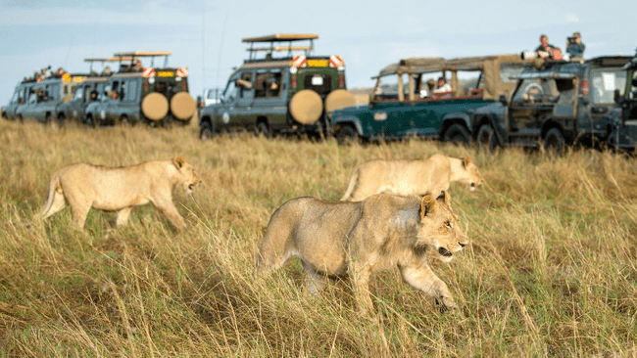
Day 6&7:Maasai Mara National Reserve  DAY HIGHLIGHT  Destination: Maasai Mara National Reserve  Time: Full Day  Accommodation:  3-star Enkorok Mara Camp  4-star Masai Mara Sopa Lodge  5-star Mara Maisha Camp  Room Configuration: Standard Double Room  Meal Plan: Full Board (Breakfast, Picnic Lunch & Dinner)  --------------------------------------  Start your day with a hearty breakfast at your lodge/Camp. Enjoy a selection of fresh fruits, pastries, and Kenyan coffee to energize yourself for the day.  Set off on a morning game drive in a custom 4x4 vehicle or safari minivan. Keep an eye out for the Big Five and other wildlife as the savannah awakens.Your guide will share more insights about the flora and fauna of Maasai Mara.  Your guide will find a serene spot in the wilderness to set up a picnic lunch for you. Enjoy a variety of freshly prepared dishes while surrounded by the sights and sounds of the African bush. You also have the chance to visit a nearby Maasai village to experience their unique culture and way of life. Engage in traditional dances, learn about their customs, and shop for handmade crafts as souvenirs.  After a leisurely lunch, your safari adventure continues. Search for wildlife and soak in the breathtaking landscapes.Head back to the Lodge/camp, where you can freshen up and relax in your comfortable room or suite.  Dinner and overnight at the lodge/camp.  --------------------------------------  Extras Activities:  - Hot Air Balloon ($550) Per person  - Maasai Village Visit ($25) Per person  ***Extras are charged separately | Pictorial Experience Highlight:  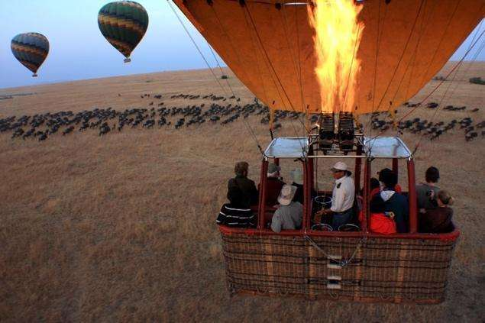  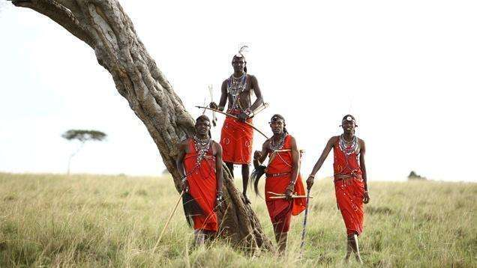  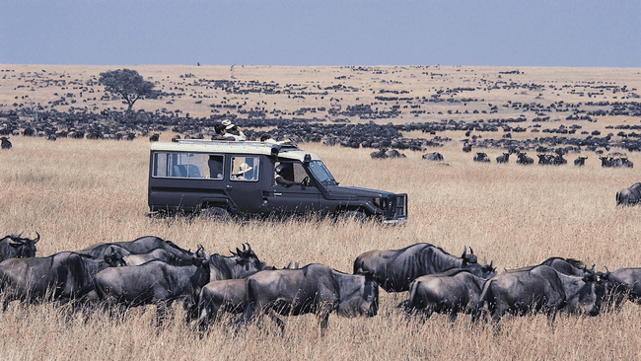
Day 8: (DEPARTURE)  DAY HIGHLIGHT  Destination: Nairobi  Distance Covered: 229.5 KM  Time: Approx. 6 hours  --------------------------------------  Enjoy a delicious breakfast at your lodge/camp. It's a perfect time to reflect on your incredible safari experiences and perhaps share stories with fellow travelers.  After breakfast, start your journey back to Nairobi. Your safari adventure may be coming to a close, but the journey back to Nairobi is another opportunity to enjoy the picturesque landscapes of Kenya.  You will arrive in time for lunch at an Indian Restaurant (pay directly) after which you will head to Jomo Kenyatta International Airport, where you'll be catching your flight back home.  Your departure from the beautiful land of Kenya can be a time to cherish the memories you've made and to anticipate your next adventure. Safe travels!  Optional Extra Activities:  - Lunch ($35)  ***Extras are charged separately | 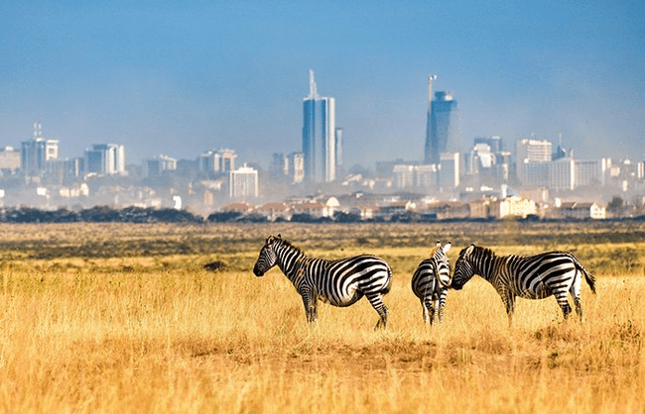  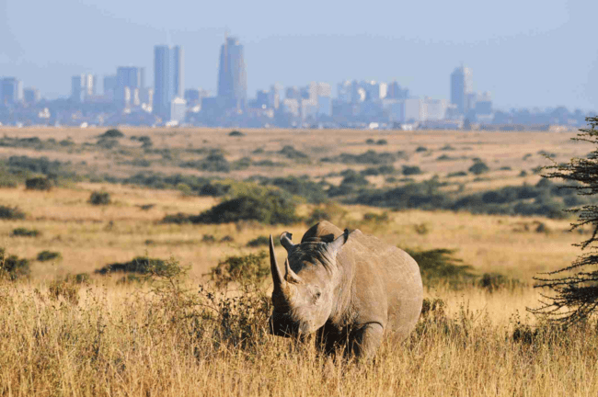
END OF SERVICES!
We wish you safari Njema!

SPECIAL SAFARI COST

3-STAR HOTELS RATES(Golden Tulip,AA Lodge Amboseli,Naivasha Kongoni Lodge & Enkorok Camp)
VALID BETWEEN: 05 January to 31 March 2024 & 01 June to 30 June 2024
VEHICLE TYPE | 1 PAX | 2 PAX | 3 PAX | 4 PAX | 5 PAX | 6 PAX
Safari Mini-Van | $3170 | $ 2070 | $2100 | $1700 | $1900 | $1580
Land Cruiser | $4090 | $2530 | $2400 | $1930 | $2090 | $1730
VALID BETWEEN: 01 April to 31 May 2024
VEHICLE TYPE | 1 PAX | 2 PAX | 3 PAX | 4 PAX | 5 PAX | 6 PAX
Safari Mini-Van | $2950 | $1955 | $1845 | $1590 | $1650 | $1470
Land Cruiser | $3870 | $2415 | $2160 | $1890 | $1840 | $1620
VALID BETWEEN: 01 July to 31 October 2024 and 22 December 2024 to 04 January 2025
VEHICLE TYPE | 1 PAX | 2 PAX | 3 PAX | 4 PAX | 5 PAX | 6 PAX
Safari Mini-Van | $4320 | $ 2800 | $2560 | $2340 | $2510 | $2190
Land Cruiser | $5235 | $3260 | $3060 | $2570 | $2700 | $2340

VALID BETWEEN: 01 November to 21 December 2024
VEHICLE TYPE | 1 PAX | 2 PAX | 3 PAX | 4 PAX | 5 PAX | 6 PAX
Safari Mini-Van | $3470 | $ 2370 | $2130 | $2000 | $1930 | $1880
Land Cruiser | $4390 | $2830 | $2430 | $2230 | $2110 | $2030

4-STAR HOTELS RATES(Sarova Stanley,Naivasha Sopa Lodge,Amboseli sopa Lodge & Mara Sopa Lodge)
VALID BETWEEN: 05 January to 31 March 2024 & 01 June to 30 June 2024
VEHICLE TYPE | 1 PAX | 2 PAX | 3 PAX | 4 PAX | 5 PAX | 6 PAX
Safari Mini-Van | $3920 | $ 2340 | $2100 | $1980 | $1900 | $1850
Land Cruiser | $4840 | $2800 | $2400 | $2205 | $2090 | $2005

VALID BETWEEN: 01 April to 31 May 2024
VEHICLE TYPE | 1 PAX | 2 PAX | 3 PAX | 4 PAX | 5 PAX | 6 PAX
Safari Mini-Van | $3110 | $1955 | $1710 | $1590 | $1520 | $1470
Land Cruiser | $4030 | $2415 | $2020 | $1820 | $1700 | $1620

VALID BETWEEN: 01 July to 31 October 2024 and 22 December 2024 to 04 January 2025
VEHICLE TYPE | 1 PAX | 2 PAX | 3 PAX | 4 PAX | 5 PAX | 6 PAX
Safari Mini-Van | $4270 | $3060 | $2760 | $2600 | $2510 | $2445
Land Cruiser | $5180 | $3520 | $3060 | $2830 | $2700 | $2600

VALID BETWEEN: 01 November to 21 December 2024
VEHICLE TYPE | 1 PAX | 2 PAX | 3 PAX | 4 PAX | 5 PAX | 6 PAX
Safari Mini-Van | $4230 | $ 2640 | $2400 | $2280 | $2200 | $2150
Land Cruiser | $5140 | $3100 | $2700 | $2510 | $2390 | $2310

5-STAR HOTELS RATES(Villa Rosa Kempinski,Ol Tukai Lodge,Enashipai Resort & Mara Maisha Camp)
VALID BETWEEN: 05 January to 31 March 2024 & 01 June to 30 June 2024
VEHICLE TYPE | 1 PAX | 2 PAX | 3 PAX | 4 PAX | 5 PAX | 6 PAX
Safari Mini-Van | $4230 | $2710 | $2760 | $2340 | $2570 | $2220
Land Cruiser | $5150 | $3170 | $3065 | $2570 | $2750 | $2370

VALID BETWEEN: 01 April to 31 May 2024
VEHICLE TYPE | 1 PAX | 2 PAX | 3 PAX | 4 PAX | 5 PAX | 6 PAX
Safari Mini-Van | $3600 | $ 2590 | $2350 | $2255 | $2180 | $2130
Land Cruiser | $4520 | $3050 | $2650 | $2455 | $2340 | $2265

VALID BETWEEN: 01 July to 31 October 2024 and 22 December 2024 to 04 January 2025
VEHICLE TYPE | 1 PAX | 2 PAX | 3 PAX | 4 PAX | 5 PAX | 6 PAX
Safari Mini-Van | $5740 | $3800 | $3490 | $3250 | $3180 | $3130
Land Cruiser | $6660 | $4260 | $3800 | $4450 | $3360 | $3285

VALID BETWEEN: 01 November to 21 December 2024
VEHICLE TYPE | 1 PAX | 2 PAX | 3 PAX | 4 PAX | 5 PAX | 6 PAX
Safari Mini-Van | $4530 | $3010 | $2760 | $2640 | $2570 | $2520
Land Cruiser | $5450 | $3470 | $3065 | $2870 | $2750 | $2670

PAYMENT OPTIONS:
- Bank Transfer:- Service charge of $35
- Secure Online Link Payment:- Service charge of 3.5% (Visa & Mastercard ONLY)
- Offline Card Payment:- Service charge of 3.5%
FESTIVE SUPPLEMENT:
An Easter supplement of US$ 40 per person, per day, will apply on the April 2nd,3rd,4th,5th 6th & 9th 2026
A festive season supplement of US$ 45 per person, per day, will apply to bookings on the following days: 24th, 25th, 26th, 31st
December 2026 & 1st January 2027
**Cancellation, T&C policies apply

COST INCLUDES:  - Meet and greet services upon arrival  - Transfers as specified in the program  - Game drives on private basis in a Safari Minivan OR a Toyota land cruiser complete with a pop-up roof  - All accommodation and meals as specified in a standard room  - Full board accommodation on Safari  - All park fees and government taxes  - Complimentary 500ml mineral water per person per day in our vehicle only  - Our assistance | COST EXCLUDES:  - International flights  - Visas  - Lunch on the last day  - Airport tax (International)  - Guide or local escort gratuities  - Drinks and dining rooms tips, porterage, personal travel and baggage insurance  - Telephone bill, laundry and any items of a personal nature  - Items indicated as optional;  - Masai village visit -$25 Per person  - Balloon safari -$550 per person  - Last day Lunch - $35 per person  - Tips and gratuities-$10 per person per day (optional)
CANCELLATION POLICY:

Tours cancellations are charged as between;

- 45 to 25 Days - prior to commencement will be subject to a cancellation fee of 35% of the accommodation cost per person.
- 25 to 15 Days - will be subject to 75% of the accommodation cost per person.
- Below 14 Days - 100% of the accommodation cost per person. We can also keep a credit note that can be utilized within 9 months

Additional Remarks:
- We may have to reroute the itinerary or accommodate in similar lodges in case of non-availability.
- Airport taxes, fuel or park fees may be changed without prior notice. This is beyond our control and any increase levied will be passed to you.

TRAVELERS NOTE:

Welcome to Kenya!

Vast savannas peppered with immense herds of wildlife. Snow-capped equatorial mountains. Traditional peoples who bring soul and color to the earth.

      - Nairobi
East Africa's most cosmopolitan city, Nairobi is Kenya's beating heart, an exciting, frenetic concrete jungle that counterpoints the untrammeled natural beauty to be found elsewhere in the country. If you're interested in learning about Kenya's culture and history, the city is home to a number of great stops including the extensive National Museum, and it's also a great jumping off point for diving into the country's varied culinary traditions. Nairobi also harbors a thrumming nightlife scene and an established cafe culture.

      - Ol Pejeta Conservancy
It was once one of the largest cattle ranches in Kenya, but is now a 365-sq-km, privately owned wildlife reserve. It markets itself as the closest place to Nairobi where you can see the Big Five and possesses a full palette of African plains wildlife, including a healthy population of rhinos. It's the rhinos that form the centrepiece of what is done here – the conservancy's 111 (at last count) black rhinos form the largest population in East Africa. A reminder of the challenges they face came when a pregnant black rhino was poached in February 2016. Though it's not just about rhinos – Ol Pejeta's role in the wider Laikipia ecosystem extends beyond its boundaries thanks to its partner agreements and wildlife corridors that link it to other Laikipia ranches.

      - Lake Nakuru National Park
Lake Nakuru is among Kenya's finest national parks. Flanked by rocky escarpments, pockets of acacia forest and at least one waterfall, the park is gorgeous year-round and is home to both black and white rhinos, lions, leopards, hippos and endangered Rothschild's giraffes. Rising water levels in 2014 forced the park's famous flamingos to flee (although a small number had returned at the time of research), and the lake is now hauntingly surrounded by drowned trees.

      - Masai Mara National Reserve
Masai Mara offers an absolutely unique variety of animals. The reason is that this hilly region is both humid and fertile, and is crossed by the rivers Mara and Talek, full of crocodiles and hippos, which carry water the whole year round. The banks of the rivers are covered in thick forest, which gradually makes way for bush and grassland. The abundance of water and excellent availability of food are the reasons why the Masai Mara, which in fact is a continuance of the Tanzanian Serengeti National Park, has the greatest population of wild animals in the whole of Africa. There is a particularly dramatic “spectacle” from July to November, the annual migration of huge herds of Gnus and Zebras. Predators such as Hyenas, Jackals, Leopards and Lions of course, closely follow these herds. Gigantic herds of over 200 buffaloes can also be observed. Plenty of food is available for elephants, giraffes, and the many species of antelopes.

